Generating Scripts: IPHIS_DB

Share Database with Data

**Steps:**

1. Go to database



1. Right Click, Go to Task, Select Generate Scripts

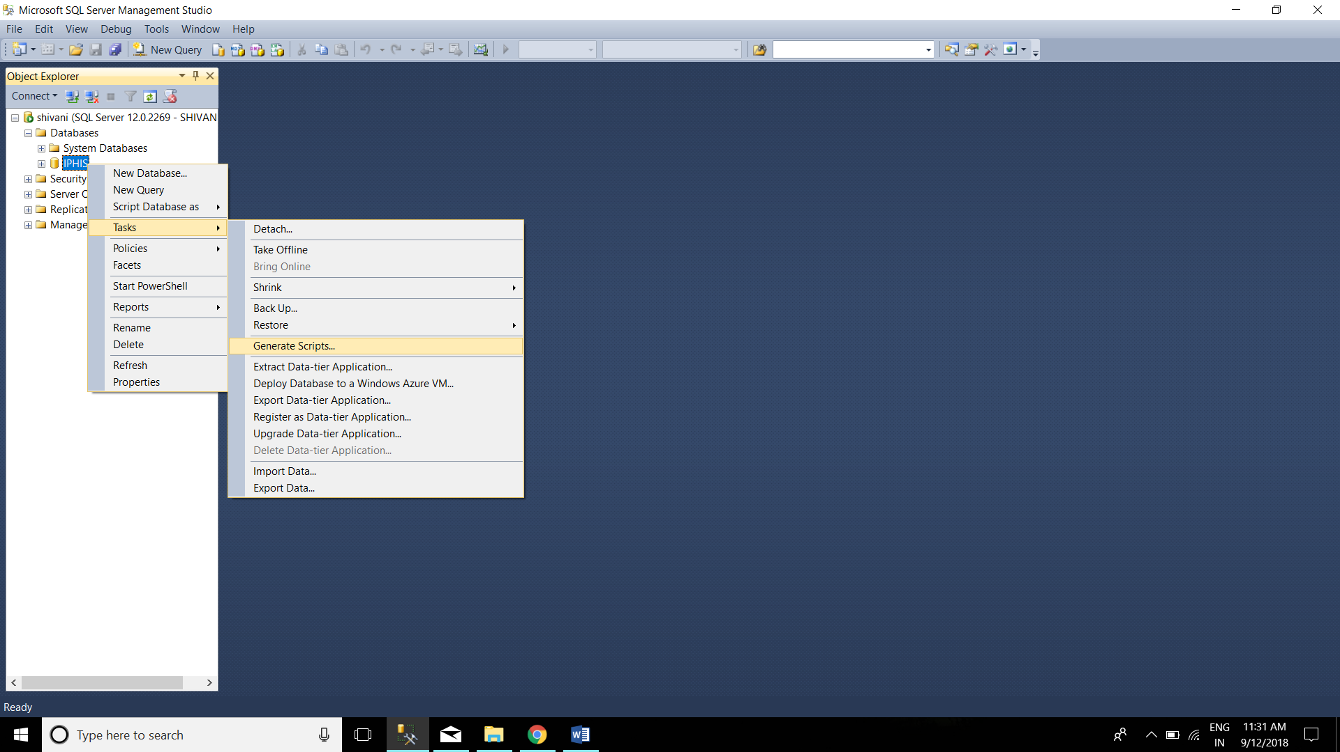

1. Click on Next

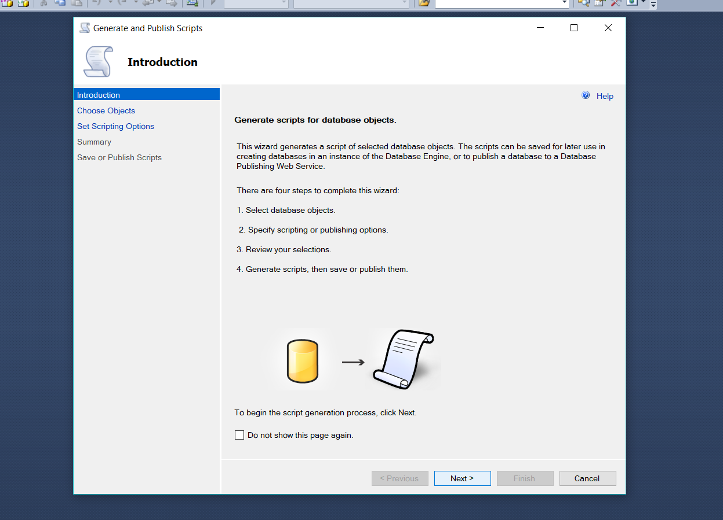

1. Click Next

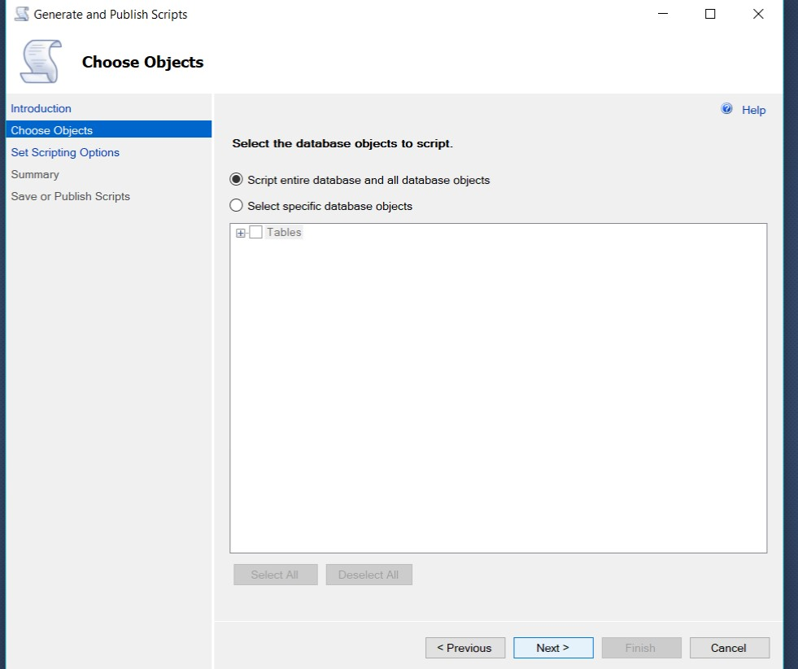

1. Click Advanced

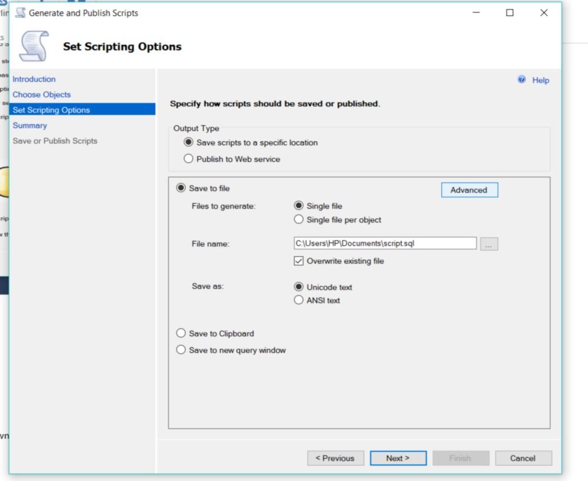

1. Select type of data to script , Change from Drop down to Schema and Data , Click OK ,Then Next.

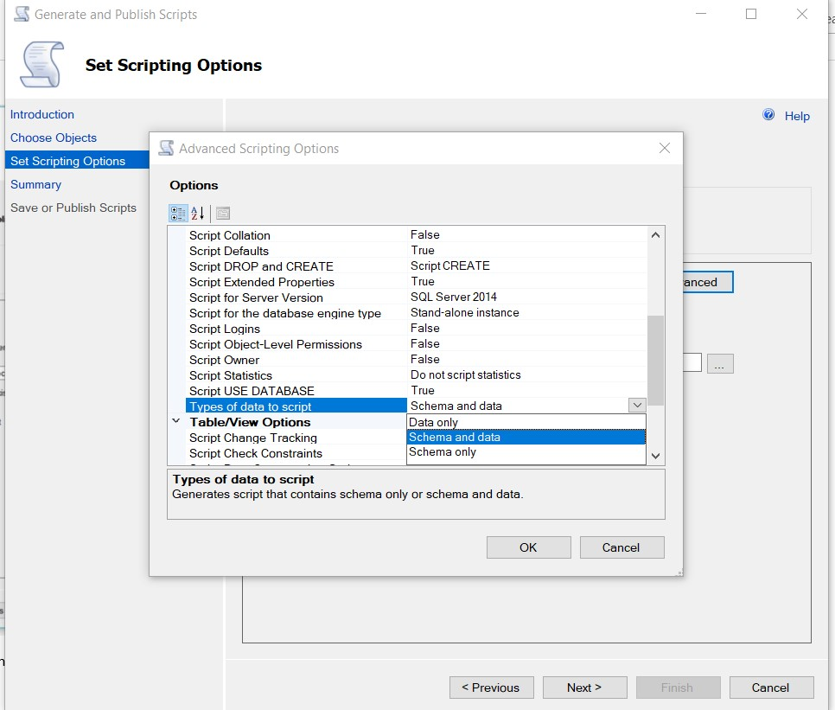

1. You will get .sql file at location, Click Next

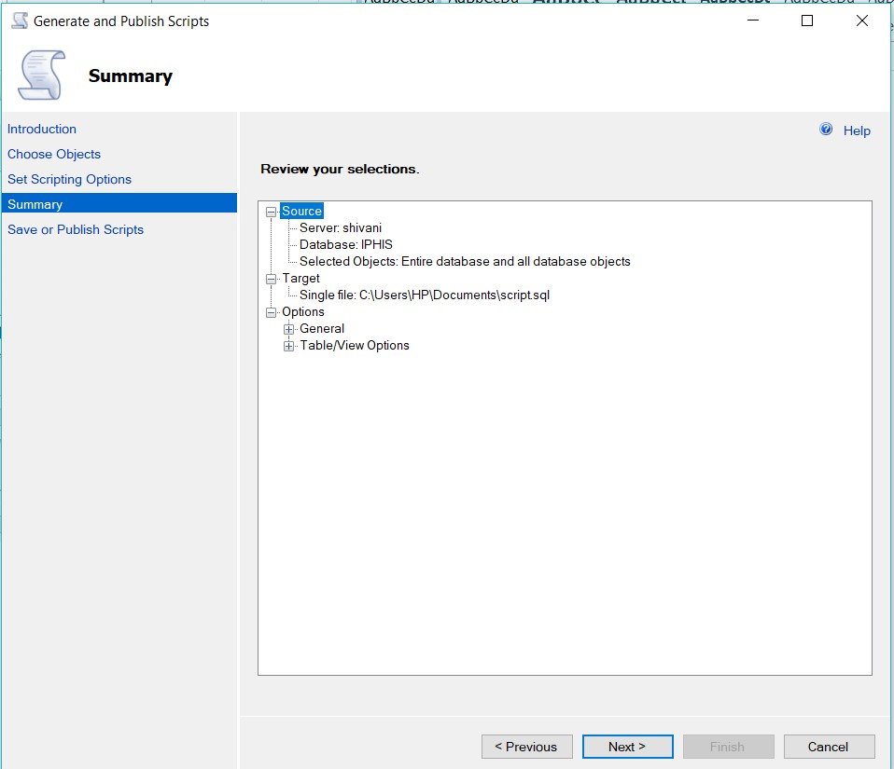

1. Process of Save or publish script, Click Finish.

